~Asia-Japan-Mirror-rc

Japanese bronze mirrors

Bronze mirrors were introduced into Japan from China and Korea during the Yayoi period (about 300 BC - AD 300). At first they had a religious function and were regarded as symbols of authority. The Japanese soon learnt to make their own mirrors using the lost-wax technique, decorating them with Chinese or native Japanese designs.

By the Nara period (AD 710 -794) mirrors were being made for everyday use, with the increasing use of Japanese designs, such as native plants and animals symbolising good fortune. From the Kamakura period (1185-1333) a design showing Hôraizan (the Chinese 'Island of Immortality') became popular.

Mirrors gradually became more robust. They mostly have a central boss, often in the shape of a tortoise, which was pierced and a cord passed through for holding. More new designs and the first handled mirrors appeared in the Muromachi period (1333-1568).

During the Edo period (1600-1868), mirrors decorated with lucky symbols or Chinese characters were given at weddings. Mirrors became larger as hairstyles became more ornate; some mirrors in Kabuki theatre dressing-rooms were up to fifty centimetres across and were placed on stands. The faces of mirrors were highly polished or burnished, with itinerant tinners and polishers specializing in this work.

Since the mirror, together with the sword and the jewel, were symbols of Imperial power, mirror-makers were deeply revered and often given honorary titles such as Tenka-Ichi ('First under Heaven'). However, this title was often misused and was officially prohibited in 1682.

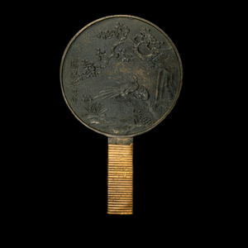

Diameter: 15 cm

Bronze mirror with a handle

From Japan  
Edo period, 18th century AD

This mirror is decorated with a perfect miniature landscape. Peacocks stand beneath a flowering plum tree beside a waterfall and winding stream. To the left irises are coming into bloom. The handle has its original rattan binding.

The mirror is inscribed Fujiwara Masashige saku (‘Made by Masashige of the Fujiwara family'). Makers of mirrors often had high status in Japan because the mirror, together with the sword and the jewel, formed part of the Imperial regalia.